**AI4Business (South Africa )**

**Tailored / Custom AI Solution’s for BUSINESS**

**TURNKEY BESPOKE AI INTEGRATION**

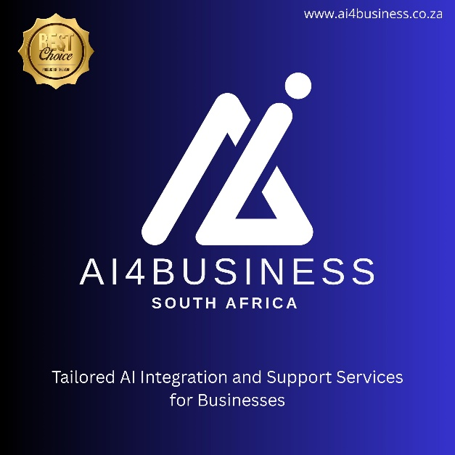

**Overview**

The document outlines the importance and impact of AI integration in businesses, particularly in South Africa, highlighting market growth, sector-specific applications, and the consequences of inaction.

**Suggest strategies for businesses to adopt AI technologies**

Based on the document, here are strategies for businesses to adopt AI technologies:

1. **Develop an AI Strategy**: Partner with experts to create a tailored AI roadmap that aligns with business goals. AI4Business offers consulting services to help businesses strategize effectively.
2. **Integrate AI Systems**: Implement AI tools and systems into existing workflows to enhance efficiency and agility. AI4Business specializes in system integration.
3. **Train the Workforce**: Invest in workforce training to ensure employees are equipped to work with AI technologies. AI4Business provides training programs to upskill teams.
4. **Focus on Custom AI Solutions**: Develop custom AI tools tailored to specific business needs, such as predictive maintenance in manufacturing or dynamic pricing in retail.
5. **Optimize and Maintain AI Systems**: Regularly optimize AI systems to ensure they remain effective and up-to-date. AI4Business offers maintenance and optimization services.
6. **Leverage AI Benefits**: Use AI for personalization, agility, risk mitigation, and operational optimization to stay competitive and reduce costs.
7. **Avoid Inaction**: Recognize the risks of not adopting AI, such as higher customer churn, increased operational costs, and longer go-to-market times. Prioritize AI adoption to prevent stagnation and ensure survival.

These strategies can help businesses transition to AI-integrated operations and gain a competitive edge in the market.

**What are the risks of not adopting AI?**

The document highlights the following risks of not adopting AI:

1. **Higher Customer Churn**: Businesses may experience a 30% increase in customer churn due to outdated processes and lack of personalization.
2. **Increased Operational Costs**: Non-AI businesses face 2.5x higher operational costs compared to AI-integrated businesses.
3. **Longer Go-to-Market Time**: Non-AI businesses take 60% longer to bring products or services to market, reducing competitiveness.
4. **Risk of Stagnation and Collapse**: Businesses that fail to adopt AI risk becoming rigid, outdated, and inefficient, which can lead to obsolescence and collapse.

These risks emphasize the existential importance of AI adoption for survival and growth in a competitive market.

**What is the projected AI market growth in South Africa?**

The document outlines the projected AI market growth in South Africa as follows:

* **2023**: $750 million
* **2025**: $1.2 billion (Projected)
* **2030**: $3.2 billion (Projected)

The market is expected to grow at a **27.23% compound annual growth rate (CAGR)**, indicating significant momentum and opportunities for businesses to leverage AI technologies.

**What capabilities does AI4Business offer?**

AI4Business offers the following capabilities:

1. **AI Strategy & Consulting**: Helping businesses develop effective AI strategies.
2. **System Integration**: Integrating AI systems into existing workflows.
3. **Workforce Training**: Training employees to work with AI tools and systems.
4. **Maintenance & Optimization**: Ensuring AI systems are well-maintained and optimized for performance.
5. **Custom AI Tooling**: Developing tailored AI solutions to meet specific business needs.

**What is included in AI strategy and consulting?**

The document does not provide specific details about what is included in AI strategy and consulting. Based on external knowledge, AI strategy and consulting typically involve assessing a business's needs, identifying opportunities for AI integration, creating a roadmap for implementation, and advising on best practices to maximize the benefits of AI technologies.

**What maintenance practices are recommended for AI systems?**

Based on external knowledge, common maintenance practices for AI systems include:

1. **Regular Updates**: Ensuring AI models and software are updated to incorporate the latest advancements and security patches.
2. **Performance Monitoring**: Continuously tracking system performance to identify and address inefficiencies or errors.
3. **Data Quality Checks**: Verifying the accuracy and relevance of input data to maintain model reliability.
4. **Retraining Models**: Periodically retraining AI models with new data to improve accuracy and adapt to changing conditions.
5. **System Optimization**: Fine-tuning algorithms and infrastructure for better efficiency and scalability.

These practices help ensure AI systems remain effective and aligned with business goals.

**What are the benefits of AI for businesses?**

The document outlines several benefits of AI for businesses:

1. **Personalization**: Higher customer engagement through tailored experiences.
2. **Agility**: Rapid response to market changes and demands.
3. **Risk Mitigation**: Prevention of failures and improved decision-making.
4. **Optimization**: Greater efficiency in operations and processes.

These benefits contribute to improved competitiveness, resilience, and innovation for businesses integrating AI.